**Name:** Cristina Pascua **Date:** 10/28/21

**Lab section:** Thursday

**Show your work!!!**

**Acquire**

Week: 36

Date: Sep. 2 Year: **2019** Data: https://data.world/makeovermonday/2019w36

**Source Article/Visualization:**

[Fall is favorite season for most Americans](https://today.yougov.com/topics/lifestyle/articles-reports/2013/06/10/fall-favorite-season-most-americans-33-heartland-l)  
Data Source: [YouGov](https://today.yougov.com/topics/lifestyle/articles-reports/2013/06/10/fall-favorite-season-most-americans-33-heartland-l)

<https://www.makeovermonday.co.uk/data/data-sets-2019/>

**Represent**

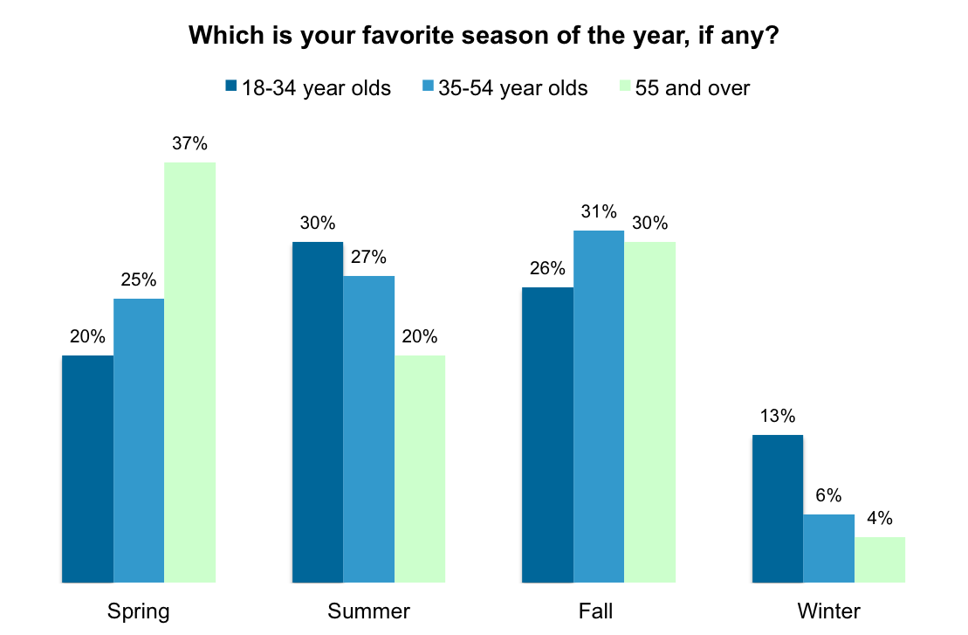

**Critique**

I think this is a good visualization as it clearly shows insight into all aspects of the data, but I don’t think it is the best way to show the insight they want. The article is titled “Fall is favorite season for most Americans” but Fall doesn’t really stand out from the rest as being the most popular. I would change this by highlighting Fall better to show that Fall is the most favorite season.

This visualization is in the Data Visualization category because it shows an overview of the seasonal preference data provided and is representing that quantitative data in a schematic form. It uses convergent thinking because it reduces complex thinking by simplifying the data into an easy-to-understand visualization.

**Mine**

I am attempting to answer the question “What is the most popular season of all ages combined?” It is the same question that the original visualization was trying to answer, but I am going to use a stack bar chart to better show this.

**Filter**

**Stakeholders**

* Who is your audience? What assumptions did you make? What visualization tool/software did you use?

**What to submit:** This document in PDF format only (if you do not know how to do this, ask).

**Choose the best layout** for your makeover visualization: Portrait or Landscape, Remove the page of the layout that you DO NOT choose. No blank pages!

**Refine (Makeover – Portrait View)**

Use an additional page if necessary. Remember, the purpose of visualization is *“insight.”* Take and include a screenshot of your visualization and include it below. Use Data Visualization Best Practices (see data visualization checklist).

Figure Caption. Preferences of season based on age groups.

**Resources**

Data Visualization Checklist:

<http://stephanieevergreen.com/wp-content/uploads/2016/10/DataVizChecklist_May2016.pdf>

How to give constructive criticism:

<https://personalexcellence.co/blog/constructive-criticism/>

Sample Makeovers

<https://www.makeovermonday.co.uk/gallery/>

**Grading Rubric**

|  |  |  |  |
| --- | --- | --- | --- |
| **Excellent**  **(21-25 pts)** | **Good**  **(10-20 pts)** | **Fair**  **(5 – 9 pts)** | **Needs Improvement (0 – 4 pts)** |
| Meets **ALL** or most of these: Makeover is esthetically pleasing (color, perception), best practices followed (insightful), Correct dataset downloaded; provided an interesting point of view of the data; critiqued previous makeover, critique is constructive (indicates one thing that is done well, and one thing that could be done differently, what will be done to improve the visualization), assumptions (more than one) are listed. | Meets **MOST** of these: Makeover is esthetically pleasing (color, perception), best practices followed (insightful), Correct dataset downloaded; provided an interesting point of view of the data; critiqued previous makeover, critique is constructive (indicates one thing that is done well, and one thing that could be done differently, what will be done to improve the visualization), assumptions (more than one) are listed. | Consistently meets **SOME** of these: Makeover is esthetically pleasing (color, perception), best practices followed (insightful), Correct dataset downloaded; provided an interesting point of view of the data; critiqued previous makeover, critique is constructive (indicates one thing that is done well, and one thing that could be done differently, what will be done to improve the visualization), assumptions (more than one) are listed. | Little to no evidence of the understanding of the data visualization process.  Lackluster makeover or no makeover.  Little effort. |